Proposal/Submission
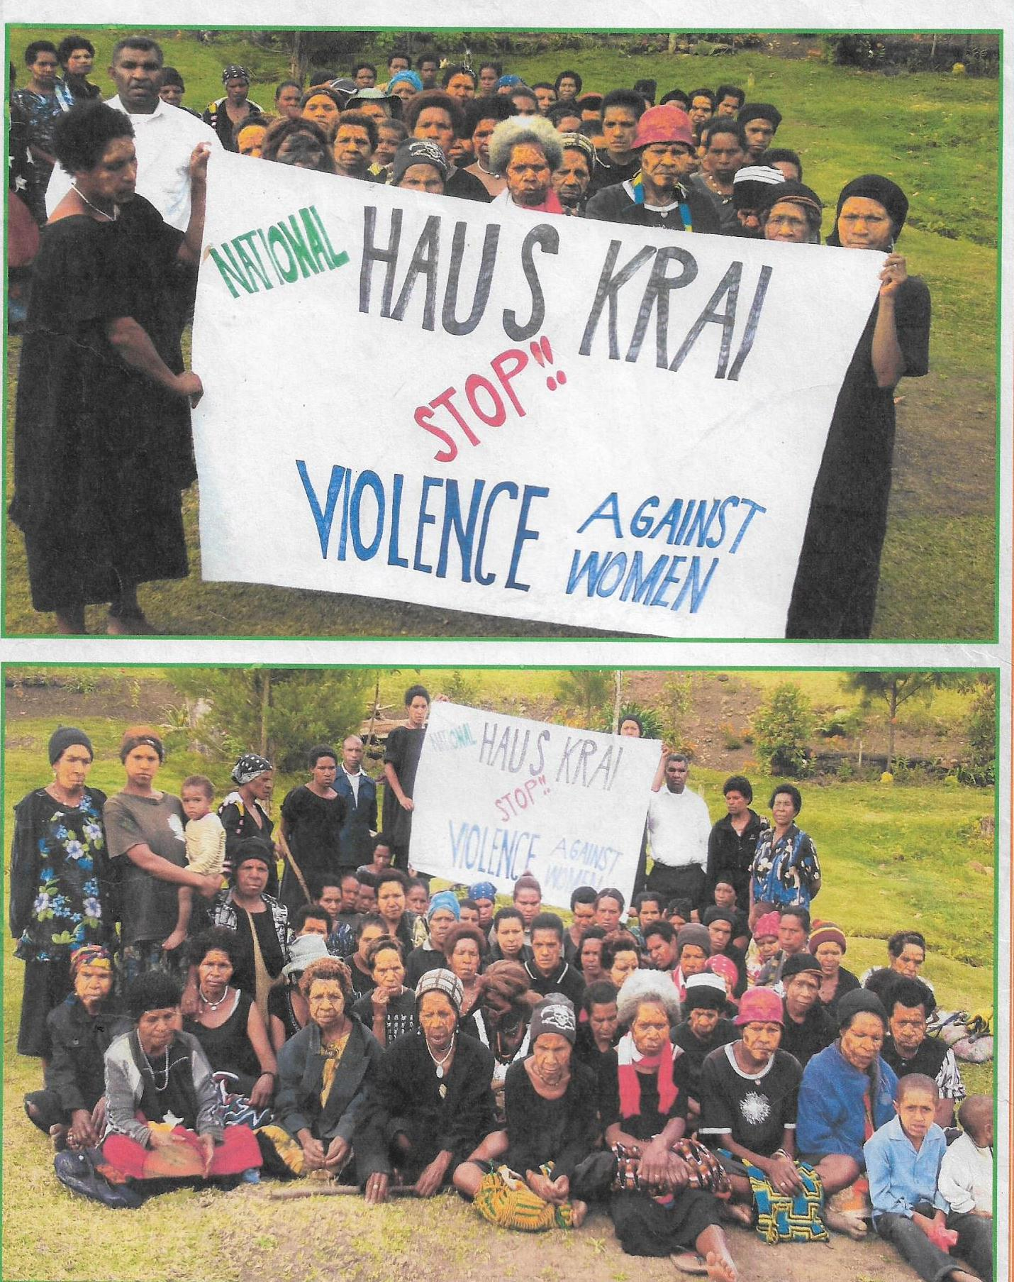
To : Special Parliamentary Committee On GBV Secretariat
From: Reverend Simon Sakul-Chairman,Jiwaka Body Of Christ.
An initiative of Jiwaka Body of Christ
(In Partnership with PNG Council Of Churches and PNG Christain Leaders Alliance On HIV/AIDS)
Project 2021

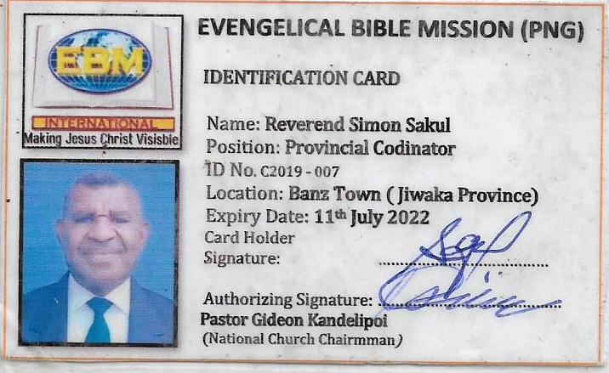
Foreword by Chairman

I would answer most of the Term of References (TOR) with answers directly derived from the Bible.
I have lived as a Christian and a clergy for 21 years and found the Bible as containing guidelines and principles that can really changes anybody.
Is is so simple that when Men/Boys change, it affects Women/Girls or vice versa.
It is a chain reaction.
The scripture that support this fact is Colossians 3:18,19
It reads verse 18.”Wives SUBMITT yourselves unto your husbands, as it is fit in the Lord.”
Verse 19.”Husband LOVE your wives and do not be BITTER against them.”
The point is clear, SUBMISSION brings, enforces LOVE.
Love heals the world and puts men and women in their perspective.
It is a natural tendency between men and women that when women submit men tend to love her and provide and care for her.
It is an order or a pattern that must be followed to achieve desired goal.

Humanity cannot change the Word of God. Humanity must be changed by the Word of God.
God Bless.

Proposal
I would answer Inquiry’s Term of Reference (TOR) in a summary form but in detail point A-H prior.
- Inquiry into the connections between GBV,gender Equality and Women’s political participation,the impact of early family planning,cultural,traditional and religious beliefs and broader social norms.

Answer: Masculinity seem to rule in this sphere.Men seem to dominate and gives no space to women.
He seemed to practice polagamy,take advantage of patrilinial society,pride of life and take advantage as men as head of the family.

(B)Identify the Immediate and long term measures to prevent Gender Based Violence,with the focus on behavior change for future generations.

Answer: (1) Colossians 3:18,19
(2) Rehabilation programmes.
(3) Women Empowerment programmes.
(4) Men/Boys involve in programmes.
(5) Funding for programmes.

(c) Inquiry into the level and impact of coordination and accountability for services and policy responses across the Government departments,the Royal PNG constabulary and related enforcement and prosecution services,the courts ,provincial and local government,non government and community based Organisations.

Answer: Women still are not served to the fullest at those place because they are poor, illerate, fear,facing all forms of Violence Against Women or threatened by men.

(D) Inquiry into the adequacy of the evidence and prevalence rate of a gender based violence and how to overcome limitations in the collection of nationally consistent and timely data including but not limited to courts,police and hospitals.

Answer: To reveal the sad truth in PNG, most of the cases in remote/rural areas go unreported because of isolation, fear, intimidation, stigma and discrimination and VAW.

(E) Identify the perpetrator intervention programs and support services to help them change their behavior.

Answer: (1) Church youth programs.
(2) Outreach programs, Awareness and Advocacy.
(3) Community work
(4) Reintroduce “Hausman”system in PNG.

(F) Consider the views and experiences of frontline services, advocacy groups and others working to address gender based violence.

Answer: (1) They must be well funded.
(2) Provided with Digital equipments (IT) to fast track and respond to emergency quickly.
(3) Women Human Rights Defenders must be protected at all times.

(G) Inquire into the gendered impacts of Covid 19 with the particular focus on the differential experience of GBV on PNG women and men ,identify how the government and other stakeholders can ensure more effective response in the context of the ongoing treats of Covid 19.

Answer: (1) Women/Girls MOVEMENTS are greatly affected during Covid 19 in PNG.
(2) Women Human Rights also affected.
(3)Violence against Women increase.
(4)Rural marginalized women suffer the most .
(5)Young girls turn to prostitution because of hunger and poverty.

(H)Inquire into how women’s leadership can be more proactively supported to ensure that women can lead the response to GBV,including by examining options for implementing temporary special measures for women in parliament.

Answer: (1) Women must be empowered in economics,politics,religious faith, and eradicate all forms of VAW,domestic violence,stigma and discrimination .

SUMMARY

As I have said earlier, Colossians 3:18, 19 is the answer to solve the issues of Gender Based Violence.

From the Government departments to stakeholders, perpetrators, frontliners, God must come first in everything.When we have reverential fear, we cannot do unlawful activities.

The End

Contact Information

Reverend Simon Sakul
Phone: 71826460
Email: simonsakul45@gmail.com

