SANDAUN PROVINCIAL GOVERNMENT
WEST SEPIK PROVINCIAL ADMINISTRATION
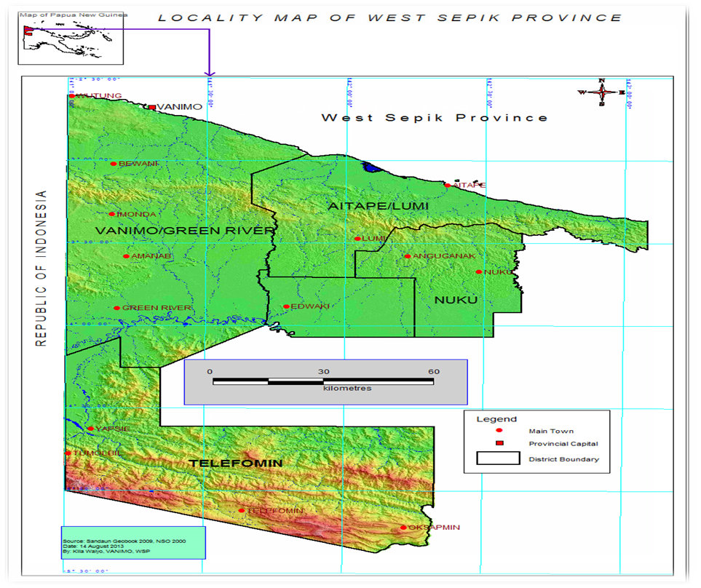

WEST SEPIK PROVINCE RESPONSE TO SPECIAL PARLIAMENTARY COMMITTEE ON GENER BASED VIOLENCE (GBV)
1.0. INTRODUCTION
In response to request by the Special Parliamentary Committee, we have some information to provide on the efforts and progress so far on Gender Base Violence in West Sepik Province.

1.1. PURPOSE
Purpose or intent of the submission to provide details, facts and information on efforts and progress on how GBV is addressed in the province. The report also outlines major gaps and weaknesses that require both the National and provincial governments support.

1.2. IMPACT OF GBV
People in the province – generally GBV is prevalent in almost in every places and communities. Every day there are occurrences of GBV of which most women girls and children are worst affected.

*Table below shows GBV cases from 2017 – 2021 in West Sepik Province

No | Particulars | 2017 | 2018 | 2019 | 2020 | 2021 | Total
1 | Physical | 1 | 15 | 5 | 9 | 7 | 38
2 | Verbal |  | 2 | 5 | 0 | 2 | 9
3 | Emotional |  | 4 | 8 | 3 | 3 | 18
4 | Rape |  | 0 | 1 | 0 | 0 | 1
5 | Adultery |  | 10 | 21 | 8 | 3 | 42
6 | Maintenance |  | 11 | 9 | 0 | 4 | 24
7 | Mediation |  | 4 | 3 | 1 | 18 | 26
8 | Early Marriage |  | 0 | 0 | 0 | 0 | 0
9 | Restraining Order |  | 0 | 2 | 0 | 0 | 2
10 | Interim Protection Order |  | 3 | 1 | 4 | 1 | 9
11 | Deserted Wife | 1 | 6 | 8 | 0 | 0 | 14
12 | Child Custody |  | 4 | 4 | 1 | 4 | 13
13 | Adoption |  | 0 | 1 | 0 | 6 | 7
14 | Denial of Resources |  | 7 | 9 | 0 | 0 | 16
15 | Others |  | 10 | 9 | 0 | 9 | 28
 | Grand Total |  |  |  |  |  | 247

Types of GBV and other cases reported in West Sepik Province

The above pie chart gave an overview for the percentages of cases of the period ending December 2020 by types of cases from the highest to the lowest reported. There were one hundred and eighty five (185) cases reported. Desertion is the highest with 24 percent followed by Adultery/Enticement and Gender Based Violence. Others with 32 percent include compensation demands and juvenile delinquency.

Raw Data for Child Protection/Welfare Cases: January – December 2020
 | Jan - Mar | Apr - Jun | Jul - Sept | Oct - Dec
Desertion/Negligence | 12 | 1 | 9 | 23
GBV/FSV | 8 | 2 | 6 | 11
Adultery | 12 | 0 | 8 | 17
Child Abuse | 1 | 0 | 1 | 5
Teenage Pregnancies | 1 | 0 | 0 | 8
Others | 17 | 2 | 7 | 34
Sub Total | 51 | 5 | 31 | 98
Grand Total: | 185 Cases

Cases are recorded in a three months period or on quarterly basis through the formal complaints presented by the complainants. Total number of cases for the year ending for 31st December was one hundred and eighty five (185).

West Sepik Provincial Administration
Division of Community Development
Child Protection/Welfare Services Data for 2020 - 2021

Category of Cases | Number of Cases
Maintenance Affiliation/Lukautim Pikinini Act | 10 cases recorded  3 court orders issued
Maintenance Deserted Wives/Children’s Act | 4 cases recorded  2 court orders issued
Adoption Act Chapter 275 | 2 cases recorded
Infant Act/Lukautim Pikinini Act | 1 case recorded and search warrant issued
Adultery/Enticement Act | 6 cases recorded  3 court orders issued
General Counselling & Case Work,  -Domestic Violence, Marital Disputes,Separation,Divorce | 15 clients attended to

The province has not drafted nor developed a Provincial GBV Strategy. It has yet to decide whether GBV Strategy would be a stand-alone or as part of the sectoral strategies under (law and justice, health).This has not eventuated in the past due to lack and change of leadership in the administration.
West Sepik Province has no annual budgetary allocation from both the National and Provincial governments to address GBV.There is also no financial assistance from the non-government organizations.
The province had just re-established its Family Sexual Violence Action Committee (FSVAC) this year 2021. (Refer to attachment for FSVAC members with contact details).
The Provincial and District GBV Secretariat is recently being established and all stakeholders have unanimously expressed that GESI office at the PHQ would lead and coordinate all activities and matters relating to FSVAC and GBV Secretariat. We have recently created a Whats app group for the GBV Secretariat namely, ‘West Sepik Province GBV Secretariat’.
West Sepik Province has only few GBV crisis support centers and services which survivors or victims of GBV go to get help. We have Family Support Center (FSC) under PHA at Vanimo Provincial Hospital, Family Sexual Violence Unit (FSVU) under Police Department Caritas PNG under Catholic Diocese of Vanimo, Lujae Home of Girls.
We do also have counselling services provided by the office of Community Development, GESI, Public Solicitors and Probations offices.
In regard to GBV prevention activities in the province, we have conducted few awareness and advocacy trainings on GBV through the office of Community Development and GESI at the provincial and the district administration levels. Not many media outreaches, education and awareness-raising is done by both the government and non-government sector officers.

GESI office in the province has been conducting good number of male advocacy trainings throughout the districts, focusing on areas of;

- Gender
- Human Rights
- Violence Against Women in PNG

(Refer to attachment on Male Advocacy Program training Guide & Internal Workplace Sexual Harassment Policy developed by GESI Office, West Sepik Province).
These two (2) important documents are used by the GESI office to train more men to increase their knowledge and understanding in GBV on;
- root causes and contributing factors of GBV
- impacts of GBV
- prevention and responding to GBV through appropriate and effective strategies
Through the GESI policy, we were able establish a network of male public servants who are sensitized and trained to advocate for women’s human rights and gender equality in their personal, professional and community lives.
There is not so much information on GBV support provided by the civil society and the development partners here in the province.

Gaps and Weaknesses
- No standardized reporting template and centralized GBV Database System is in placed
- Lack of accurate and timely GBV data from districts and LLGs to PHQ
- Poor communication and road network, geographical location, financial and other capacity needs are some of the major factors affecting the effectiveness in the delivery of GBV programs and activities
- Lack of education and training on GBV management
- Poor coordination and consultation at the national,sub-national,districts and LLG on GBV issues
- No local/internal policies to address GBV
- No Annual Budgetary Allocation for GBV by National/Provincial Governments

- The gaps and weaknesses outlined are also our recommendations/ resolutions and way forward to address GBV in West Sepik Province thus, help to eradicate GBV throughout the nation as well.
Report Compiled by: Endorsed/Approved by:
________________ ____________________
Vincent Kowolou Conrad Tilau
Manager GESI Provincial Administrator

