

WEST NEW BRITAIN PROVINCE GENDER BASED VIOLENCE ACTION COMMITTEE (GBVAC) STATEMENT TO;

SPECIAL PARLIAMENTARY COMMITTEE ON GENDER BASED VIOLENCE, DONOR PARTNER AND NATIONAL GBV SECRETARIATE ON GBV ACTIVITIES AND DEVELOPMENT UNDERTAKEN IN WNBP.

BY:

MR. WILLIAMSON HOSEA

PROVINCIAL ADMINISTRATOR

WEST NEW BRITAIN PROVINCIAL ADMINISTRATION

DATE: 01st – 03rd December 2021

His Excellency Hon. James Marape, MP, Prime Minister

Hon. Charles Abel, Chairperson of the Special Parliamentary Committee on GBV

Members of the Special Parliamentary Committee

Fellow Leaders and distinguish delegates

It is with great honour for me to provide to the committee and stakeholders an update on work undertaken so far by my administration and government in establishing the basic building blocks in as far as ending GBV is concerned in my province.

The status of GBV work in the province is progressing at a medium phase that is because of the gentle support from Hon. Sasindran Muthuvel Governor of West New Britain Province and Hon. Francis Galia Manake Member of Talasea District and a member of the Coalition member of Parliamentarian to end GBV in the Country PNG.

Special thank you to the Talasea Open Member Hon. Francis Galia Maneke during his reign as Governor of the Province for supporting the work of Gender Based Violence in the Province. His work is so significant in this space hence through the Provincial Executive Council have endorsed the following;

1. The Establishment of the Provincial Gender Based Violence Action Committee (GBVAC)

(Refer attachment of; PEC decision, Committee listings and GBVAC Establishment report)

1. WNB Provincial Gender Based Violence Strategy Plan 2021-2025;

(Refer attachment of; PEC decision, Strategy Plan 2021-2025 copy and the endorsement of the five-year budget.)

**Hon. Chairman**

I also wish to extend my utmost gratitude to UNDP, UNFPA and other partners for their continuous technical support to our province even though WNB is not formally engage as the spot light province thus you have recognized our effort and the commitment, we have for our province to end GBV prevalence’s that are arising in our societies.

**Hon. Chairman**

My administration and the government have noticed GBV as a development concern and global agenda and we will ensure this agenda is pursued and addressed at all levels to attract support from our external partners private sector organizations and Government of Papua New Guinea to support all the programs and projects relating to GBV in the province.

**Scope of GBV in WNBP**

**Hon. Chairman,**

The scope and the nature of GBV in West New Britain Province is as similar to other provinces. It cuts through every segment of the society. Gender-Based Violence prevalence has no limit; hence, it causes so much of socio-economic disorder among individuals, families and communities in the West New Britain Province. Gender-Based Violence acts are not limited to certain areas, they are quite prevalent in any forms of relationships, whether, boy-girl relationships, marriages, and between friends of same gender. GBV acts occur all levels including villages, communities and the political level as well.

**Nature of GBV in West New Britain**

**Hon. Chairman**

The nature of Gender – Based Violence, as in the West New Britain Province’s case, is so much influences by change in the style and way of living. The growth within the development space within social and economic domains in the province, especially, in the northern part of the province has directly triggers the multi-cultural affiliations which changes the mindset of both the indigenous and settlers.

The acts of GBV in West New Britain is triggered by and influenced by multiple factors including external pressure from different cultures and mindsets from other provinces, and the indigenous cultures and traditions from societies within the province. Individuals have either somehow have one or more affiliations either within their indigenous culture & traditional setting or culture & traditions from outside the province. These affiliations eventually contributed directly or indirectly to conflicts within relationships between men and women. The diagram below demonstrates the influences the conflict between the relationship of a man to men, woman to woman or man to woman.

**INFLUENCES OF CONFLICT BETWEEN MEN AND WOMEN**

Furthermore, there are also other micro affiliations regarded as **Indirect Affiliations**.

These types of affiliations refer to relationship that somehow may have a direct influence on a man or a woman’s relationship. These include workmates, peers, or friends around you which in one way or the other interfere with your internal affairs. These are well demonstrated in the diagram above. The factors associated with the Gender-Based Violence issues will be highlighted in the following section.

**Factors Associated with GBV (WNBP Case)**

**Hon. Chairman**

Given the multi-cultural affiliations of the West New Britain Society, internal and external influences have contributed so much to the mix culture and eventually triggers the rise in the GBV acts in any community or society within the province. Most of these are common, and obviously are reflected in most literature that are produced by research scholars. However, in this instance, we will provide the factors based on the WNBP’s perspective. Out of the most cases 40% of the cases relates to violence caused within marriages. 20% of the cases are alcohol related and 20% of the cases caused as a result of land disputes. The chart below shows the causes of violence in the West New Britain Province.

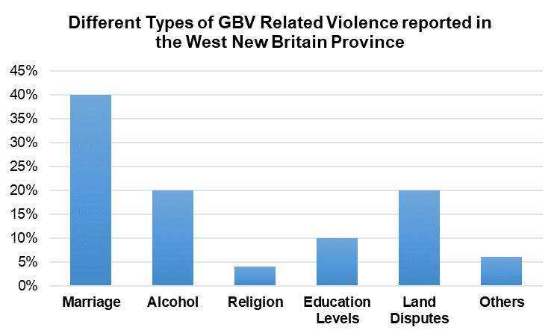

No. of different cases reported in 2020

***Source:*** *Division of Community Development, WNBP*

**Hon. Chairman**

The main causes of Gender-Based Violence in the province are further outlined in detail below and they include;

1. **SOCIAL FACTORS**

* **MARRIAGES**
  + Marital Status

Marital status of person determines the level dependency that person (whether male or female) has to sustain its livelihood during his or her survival.

* + Inter-marriages – Conflict in Bride Price payments

Inter-marriages, especially, marriages between cultures & traditions have a negative impact on the couples. This is applicable when negotiating bride price payments, i.e., bride price in some cultures signifies the total ownership of the bride other than any other obligations set apart from total ownership.

This gives men the upper – hand over their female counterparts in any circumstances with conditions applied.

* + Second and third type of marriage

Second and third types of marriages are so vulnerable to any form of Gender – Based Violence, whether, domestic or external. In so many cases, understanding lacks from this type of marriages. Men or women may still have past experiences with previous relationships; therefore, it creates instability among the male and female spouses.

* **ALCOHOL**

Alcohol can be associated with GBV in many ways. Consumption of alcohol is a factor that is directly triggers domestic violence or public nuisance may attract bashing or killing in this instance.

* **MARIJUANA**

As similar to alcohol, Marijuana consumption is now common among youth and is an issue in the province. Consumption of Marijuana may directly trigger domestic violence, killing, or any other form of abuse.

* **CONFLICT OF RELIGION**

Conflict between religious groups is very common nowadays in the province, especially, in the village and urban setting. Different ideologies and doctrines contradict each other and commotion in the teachings becomes sensitive between church workers, preachers and the general public.

* **LEVEL OF EDUCATION**

It is also noticed notices persons with lower level of education are suppressed from information, and somehow, have difficulty in understanding and comprehension. The level education also paved pathway for establishing a class-based system. For instance, people with high level education consider themselves as superior to the less education. Therefore, out of the 50 people interviewed, more than 50% do not have access to sufficient information relating to GBV. These people are mostly people with limited education. The chart below demonstrates the level of information sharing between different groups.

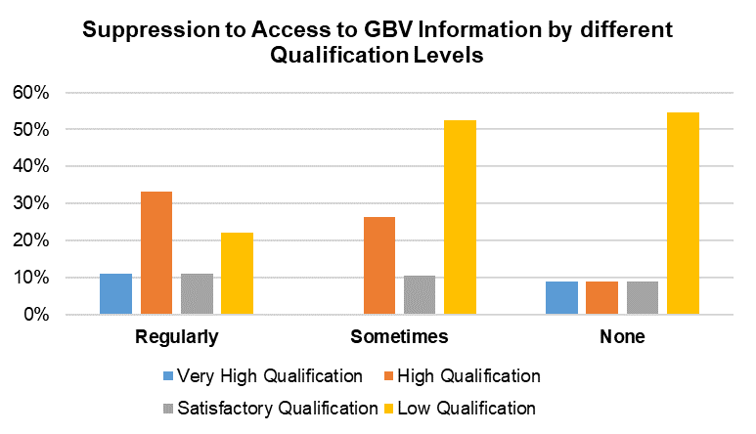

***Source:*** *Division of Community Development, WNBPA*

**INFLUENCES FROM COLLEAGUES AND FRIENDS**

We may think that the main pressure and influence comes from the internal and external factors including outside and indigenous cultures. However, that the certain levels, work mates and close friends has huge impact in the relationship between a man and a woman.

1. **ECONOMIC FACTORS**

* **Lack of Financial Incentives**

Some people have no financial motivations at their door steps. Even though palm oil is so prominent but is quite limited to those who have access to land. People don’t have access to better market facilities or other opportunities offered by the relevant authorities.

* **Financial Vulnerability**

The Oil Palm Industry has so much influence through the establishment of the Land Settlement Scheme that was introduced in 1969. Though it provides the best available income through oil palm harvest but as the extension of the nuclear family to a more sophisticated extended family living, conflict began to occur between families, especially, between the off-springs. The 2-hacter of Oil Palm block served very low income as compared to ten (10) years back then. For instance, as the size of an individual family increases the kina value within the family domain decreases. This trigger so much tension between family members and eventually results in physical assault or crime.

* **Land Scarcity**

The population has grown by 30% from 2010 which causes the population density to 5 or more people per 1 hectare of land. This implies that land has become scarce in the sense that people cannot own land but extend to non-conducive land for survival, especially, to cultivate and produce food for consumption. The most of the arable land has been occupied by Oil Palm plantations through the Village Oil Palm concept. This issue triggers other issues such as land grabbing, etc. This eventually causes between clans, individuals and others.

* **High Unemployment Rate**

Unemployment youths in both settlement camps and indigenous population are highly involve in the consumption of illicit substances (e.g., marijuana, matuka (home brew) and bag snatching.

Consequences of GBV

Hon. Chairman

Gender-Based Violence has caused so much detrimental impact on relationships between men and women and has a significant impact on individuals. Causes of GBV may vary from different settings but from the WNB perspective, the causes of GBV include;

* Victims suffer from Physical and Mental effects
* Health consequences are; injuries, untimed or unwanted pregnancies, Sexually Transmitted infections, genital injuries, pregnancy complications, miscarriages
* Physical and Emotional harm to victims and children, i.e.: ongoing anxiety and depression. Emotional distress, eating and sleeping disturbances
* Post traumatic disorder and suicide
* Broken marriages and displaced children
* Death
* Children growing up in a violent home or community tend to see violence as a legitimate means of getting what they want.

**Status of GBV Acts in West New Britain Province**

**Hon. Chairman**

During the process and procedures in the formulating any plans, it is much better we consider our status. In this essence, when designing and formulating this strategic plan, we reflect our on status using the available data. We consider this based on two (2) significant aspects; firstly, the GBV status will set out our focus or direction, and secondly, it will determine the priorities in addressing GBV issues in the province. The status of GBV Cases in WNBP is so much of empirical in a sense that, representation of the data/information provided as per requirements, may not be accurate, but a trial in this manner tries to depict the status of the GBV programs run by the West New Britain Provincial Administration.

Therefore, based on the available data provided by the Division of Community Development (data for 2020 only), shows a tremendous effort put in by community development officers as shown in the table.1 below and the trend shown in chart.1, mediations are very high as the number of maintenance cases seemed quite common apart from other cases. The number of wives bashing and neglect cases have also indicated a consequential result registered in 2020. Other cases registered have indicated low number of cases committed by the perpetrators from January to December in 2020. The chart on the next page, depicted the level of GBV Cases in 2020.

As a matter of fact, the results indicated in the chart below indicated that only 30% of the GBV related cases are reported but 70% are not reported due to unknown reasons. This can be attributed towards neglect or incompetency.

**Chart.1.** The trend of Number of GBV Related Cases committed in 2020.

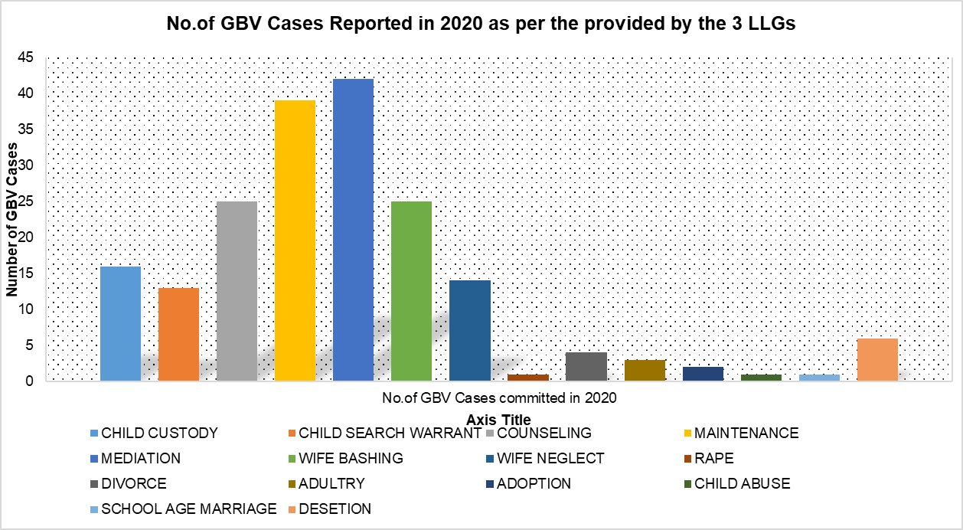

**Source:** Division of Community Development, WNBPA

As stated earlier, data and information set presented through various means exemplifies the need to improve on the monitoring and reporting aspects of the entire strategic framework.

Registered number of GBV Cases (Selected LLGs)

Hon. Chairman

The table below shows the number of GBV cases that were registered in 2020 and classified based on the nature of cases.



**Source:** Selected LLGs, WNBPA

**Hon. Chairman**

The Provincial Gender Based Violence Committee anticipates to improve on its annual operations, providing the fact that coordination of internal functions. relating the programs and activities ought to be linked between the two (2) district and all twelve (12) LLGs. Given the current feedback, it shows that there is lack data management. However, the current trend shows that the Talasea LLG registered the greatest number of GBV cases than East Nakanai and Kimbe Urban LLGs. This picture may not depict the actual story, but may reflect two (2) scenarios; a. Effort of the LLG CDOs; or b. Frequency of Cases. The prevalence in the GBV cases appears to be around 13 to 14 case per month in one particular LLG on **Average.**

**Chart.2.** The trend showing the status of GBV cases by LLG (as per selected).

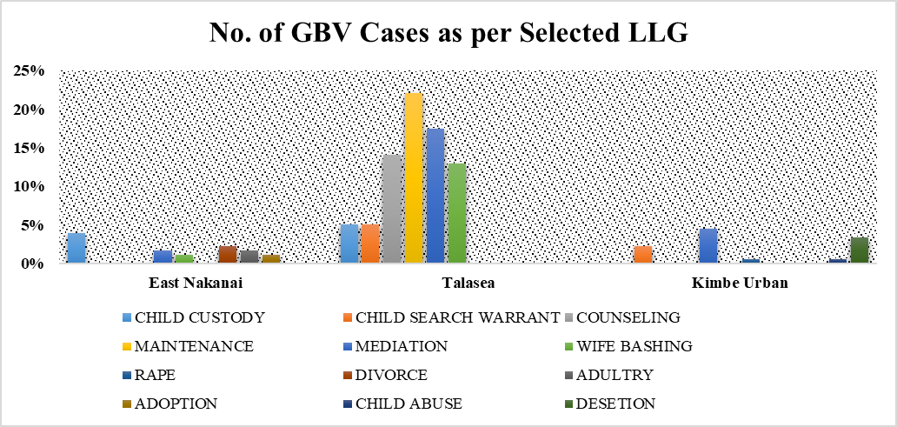

**Talasea LLG is doing a better job in terms of reporting**

**Source:** Division of Community Development

Average performance is still satisfactory but the connotation of the actual assessment may be questioned based on the level information and data provided. This is very significant to the fact that concrete data can be used to measure the utmost outcome anticipated by this strategy.

However, in this segment we try as much as possible to produce more information using the available data in this stage. The information produced in the segment determines the next steps for improvement; and as well, it provides the benchmark for information such as;

1. Frequency of GBV Cases as per LLG;
2. Efforts towards addressing GBV in all LLGs; and
3. Determines the next possible approach to address the GBV cases based on the Frequency of cases.

**Hon. Chairman**

The most signifying factor among other odds is that, the prevalence in GBV cases occurs frequently in the Talasea LLG, whereas, cases in East Nakanai and Kimbe Urban LLGs fall below the average line. This does not mean that these two (2) LLGs were not prone to the causes of Gender-Based Violence, but may be most cases were not reported. The lack of reporting of GBV cases are caused either by two (2) factors and they are;

1. Lack of accessing facilities; or
2. Unwillingness to report such GBV incidences

Take for instance, most serious GBV cases such as rape, incest, physical assault, remain very low (as per the data in table.1) but in an ideal situation, this appears to be more unrealistic as many communities are **NOT** responding due to unwillingness to report perpetrators to the authorities. Therefore, as part of the current data interpretation, it is quite common that reporting of GBV incidences are from the areas that have better access to community development facilities than those which are very remote.

**Chart.3.** The prevalence in locations-Ideal Situation versus Current Data.

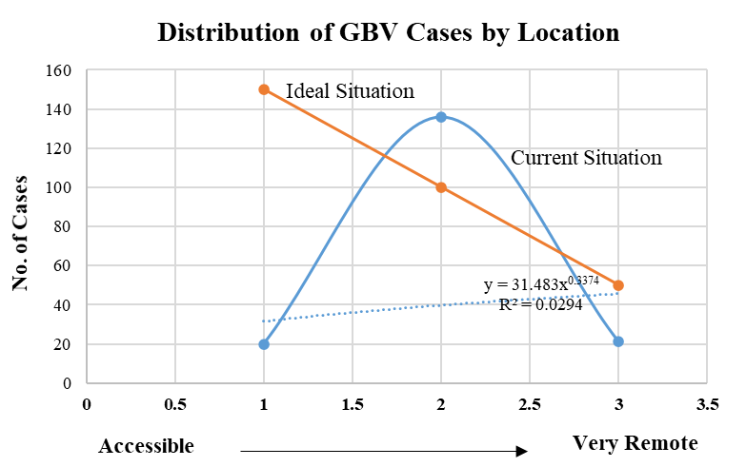

***Source:*** *Division of Planning, Coordination & Monitoring, WNBPA*

**Hon. Chairman**

In contrary, scenario demonstrated by the orange line in chart.3. does shows the ideal situation in relation to GBV cases. We understood the perfection in the anticipated data but the ideal situation predicts that the more we have better access to facilities, more GBV incidences should be report and registered than in locations which have the challenge of accessing facilities.

However, improvement in data collection and classification will dearly pave way for better analysis, processing of information and producing of enough information relating Gender-Based Violence for public consumption.

As a matter of fact, such data is very useful and, in this respect, set the first stage of redesigning and framing of the current approaches towards addressing Gender-Based Violence in communities to improve livelihood of our mothers, sisters, daughters and the young children of this generation of the West New Britain Province.

The Division of Community Development has taken this proactive approach by formulating this strategic plan to guide our approach to address GBV incidences. We may put our focus towards scientific approach but simple approach may will counter act to the situation.

**WNB Provincial Government Approach towards addressing GBV**

**Hon. Chairman**

As per the data/information presented, the WNBP GBV Action Committee through the Division of Community Development has taken a holistic approach in addressing the Gender-Based Violence in the province. It has used two (2) methods of approaches which includes;

1. **Direct Approach:** The first approach includes the *“Direct Approach”* which involves the effort from all stakeholders. This is an approach that encourage direct contact in utilizing all available resources including time, finance, and human resources to combat the GBV prevalence in the province. Chapter four (4) on the “Rationale and Frameworks” and Chapter. Five (5) on “Strategic Priority Action Areas” demonstrates the current approach.
2. **Indirect Approach:** The second approach relates to existing pillars and foundation set by existing policies and plans. These plans and policies were developed and formulate to address GBV indirectly at the different levels and domains within the communities. This approach concurrently tried to address this situation socially and economically. Some of these policies and includes the;

**WNBP Policy on Informal Economy (Sector)**

**Hon. Chairman**

The current of the WNB Informal Sector Policy is to change the current approach to ensure that the 89% of the rural population benefited in this policy. This policy provides the platform based on the number of factors that we feel that it will benefit ordinary people by providing;

1. Equal Economic Opportunities;
2. Equal Participation in the domestic economy; and
3. Well controlled Informal Sector

**WNB Integrated Provincial Development Plan**

**Hon. Chairman**

This WNBIPDP is our second midterm plan that is our home-grown policy document which is aligned to the various National Governments Development plans and policies. The WNBIPDP will also enable our divisions and agencies to prudently implement their prioritized programs and develop implementable activities and that all stakeholders embrace these strategies and contribute tangible development of the province.

The Ward profile and development project has also ensured that individual wards in the province have a development Plan that is align to this integrated development plan. These plans will be collated to form the LLG plan and likewise every LLG plan will be collated to document the District Plans. This integrated provincial development plan basically integrates the National Strategies with those of the Districts and LLG Plans.

**Hon. Chairman**

I’m pleased to advise the committee that my administration and government is committed to the cause and hence following the GBV Summit and the Provincial Coordination Workshop held in Port Moresby in November 2020, we have established a Provincial GBV Action Committee comprising of nineteen (19) various stakeholders. Immediately after its establishment the Committee with the assistance of the Divisions for Community Development and Planning embarked on the formulation of a GBV Strategic Plan 2021 – 2025 as a guide for the province in ending GBV going forward.

**Hon. Chairman**

West New Britain Province is among the few provinces that have developed the GBV strategy plan. Below is the snapshot of the plan outlining the Strategic Priority Action Areas (SPAA) and the total funding budgeted to effectively implement the Strategic Plan from 2021-2025.

In the strategy, we developed twelve (12) Strategic Priority Action Areas (SPAA). These SPAA are clearly specified by their key activity, output indicator, the responsible agency, and the estimated budget for each SPAA. Furthermore, these SPAAs are then demarcated into each level including the districts and Local Level Governments. These include; Planning, Policy Formulation & Creating Pathways; Stakeholder Engagement; Community & Persons Engagement; Effective Counselling & Advocacy; Capacity Building; Enabling Infrastructure; Research & Development; Coordination & Awareness; and Review/Evaluation.

|  |  |
| --- | --- |
| STRATEGIC PRIORITY ACTION AREA | ALIGNMENT TO NATIONAL STRATEGY |
| SPAA.1: Establish the WNBP Gender-Based Violence Action Committee | Outcome.1, Output.1.1, Activity.1.1.1 & 1.1.2 |
| SPAA.2: Planning, Policy Formulation and create enabling Pathways. | Outcome. 1, Output.1.1, Activity.1.1.1 & 1.1.2.**vity.1.1.1 & 1.** |
| SPAA.3: Stakeholder Engagement | Outcome.1, Output.1.2, Activity.1.2.1 |
| SPAA.4: Community and persons Engagement | Outcome.4, Output.4.2, Activity.4.2.2 |
| SPAA.5: Effective Counselling and Advocacy | Outcome.3, Output.3.1, Activity.3.1.1 & 3.1.2 |
| SPAA.6: Capacity Building through Training | Outcome.4, Output.4.2, Activity.4.2.2 |
| SPAA.7: Enabling Infrastructure | Outcome.3, Output.3.1, Activity.3.1.1 & 3.1.2 |
| SPAA.8: Organizational Control & Capacity Building | Outcome.4, Output.4.2, Activity.4.2.2 |
| SPAA.9: Establish a Provincial and District Data Management Systems & Research | Outcome.2, Output.2.1 & 2.1., Activity.2.1.1 & 2.2.1 |
| SPAA.10: Coordination and Awareness/Advocacy at the Districts | Outcome.3, Output.3.1, Activity.3.1.1 & 3.1.2 |
| SPAA.11: LLG Coordination and Mobilization | Outcome.1, Output.1.1, Activity.1.1.1 & 1.1.2 |
| SPAA.12: Ward/Community/Village Mobilization and Engagement | Outcome.3, Output.3.1, Activity.3.1.1 & 3.1.2 |

Hon. Chairman

The West New Britain Provincial GBV Strategic Plan 2021-2022 is to be implemented for 5 years (2021-2022) and has proposed budget of **K7,187,000** which **K6.3 million** is allocated towards Enabling Infrastructure, that’s for the three (3) proposed family support centres for Talasea and Kandrian/Gloucester Districts and Province as per IPDP reference; and **K200,000** for Research and Development.



**Hon. Chairman**

The WNBP GBV Strategic Plan 2021-2025, is a document that outlines the approaches anticipated to guide the implementation of the National Strategy to address GBV in Papua New Guinea. This strategic plan is designed and developed in such as a matter that it reflects the main aim of the overarching policies and legislations including the MTDPIII, PNGSDP and Vision 2050 to address GBV in all societies of PNG. This also embraces the five (5) main principles of the Constitution of Papua New Guinea. By doing so, we will ultimately achieve the vision of ***“West New Britain Province be a peaceful, health, wise and fair society that promotes and upholds human dignity through socioeconomic empowerment for sustainable growth”.***

**Hon. Chairman**

The Provincial Gender- Based Violence Action Committee (GBVAC) through Community Development Division have conducted the mapping on the information regarding the GBV prevention activities in the province targeting the organizations that were directly addressing GBV issues in their space. The organizations responded are; Hargy Oil Palm Limited (HOPL), Public Health Authority (PHA), Police FSVU, Magisterial Services and the Provincial Office of the Family and Child Services. **(Refer attachment of the partners organisation report)**

**Hon. Chairman**

In West New Britain we did not have a designated safe house to place the GBV survivors in thus we have partners and individuals who are actively working in this space assisting GBV survivors and keeping them safe in their own family homes.

In the WNBP Gender Based Violence Strategy 2021-2025 No. 7 Strategic Priority Action Area is focus on Enabling Infrastructure which K6.3 million is allocated towards building three safe houses over the period of five years.

**Hon. Chairman**

Below are partners and individuals using their family homes to shelter the GBV victims. These individuals are sacrificing their family time, resources just to spare a life of GBV survivors hence on the other hand they also putting their life at risk for the attack from the defenders. These partners and individuals operating without proper safe house facilities.

|  |  |  |  |  |
| --- | --- | --- | --- | --- |
| Number | Organization | Operator | Type of service | Contacts  Phone:  Email: |
| 1 | **Patwe Out of Home Care Centre** | **Florence Kunia** | * **Out of home care placement** * **Shelter for GBV/DV Victims** | **Ph: 73557634**  **Email:** |
| 2. | **Yellow Ribbon** | **Jennifer Aigilo** | **Shelter for GBV/DV Victims** | **Ph:71441233**  **Email:** |
| 3. | **WNB Meri Seif Haus Association** | **Rhonda**  **Fishi’hoi** | **Shelter for GBV victims** | **Ph: 72536062**  **Email:** |

**Hon. Chairman**

Given the situation and the current status West New Britain Province is now in- terms of addressing Gender Based Violence, Following are recommendations that I would like to recommend to the Special Parliamentary Committee on GBV and the National GBV Secretariat for your considerations;

1. West New Britain is similar to other sister provinces that don’t have GBV data Management system. The Provincial Gender Based Violence Action Committee has to have a main data system where it links with all our provincial partners and stakeholders for report submission. The National GBV Secretariat has to seriously consider allocate more funding coming year 2022 to establish 22 x Provincial Data Based system aligning to the National GBV Data Management System.
2. In the WNBP Gender Based Violence Strategy 2021-2025 No. 7 Strategic Priority Action Area is focus on Enabling Infrastructure which K6.3 million is allocated towards building three safe houses over the period of five years. I urge and recommend to the Special Parliamentary Committee on GBV, National GBV Secretariat and interested donor partners to partner with West New Britain Provincial Government to counter fund the establishment of at least one Safe house next year 2021.
3. I anticipate next year 2022, National Government will allocate huge funding towards the work of ending GBV prevalence in the country. The county made up of Provinces, Districts, LLGs and its inhabitants. The money should put to a good use in addressing the GBV pandemic in the provinces, districts and LLGs so the citizens can have a safer place to live with violence free society. I urge the National GBV Secretariat should consider giving first preference to provinces that has already developed their GBV Strategy plan when it comes to funding support.

**Hon. Chairman**

I now come to my conclusion and I thank you for the wonderful initiative taken to bring all the twenty-two provinces gathered here today to publicly hear our concerns and issues faced in the work of addressing GBV prevalence in our respective provinces.

WNB Provincial Government cannot address GBV issues in the province alone, but we need support from all stakeholders and partners to address this agenda bring the development of our province forward. The GBV pandemic is a development issue which directly affects our society, the people especially, our mothers and children in the communities. Let us continue with the good work that we started and proceed to save our families, communities and the province as a whole.

On behalf of the people of West New Britain Province, with the highest respect, I kindly ask our heavenly Father for his wisdom and guidance all through the implementation of the GBV programs and activities in the province.

May God bless us all.

Thank you

_______________

**Williamson Hosea**

Provincial Administrator

WNB Provincial Administration

Kimbe, WNBP

Find in the tabula below list of documents as a prove of the work WNBP has done so far in the GBV space. Copy of actual documents are also attached.

|  |  |
| --- | --- |
| **ATTACHMENT LIST** | |
| **List** | **Description** |
| Attachment: 1 | PEC decision on the Establishment of WNB Provincial GBVAC |
| Attachment: 2 | GBVAC Establishment Report including Membership List |
| Attachment: 3 | PEC decision on the Approval of the WNBP GBV Strategy Plan 2021-2025 |
| Attachment: 4 | WNBP GBV Strategy Plan 2021-2025 |
| Attachment: 5 | Copy of PHA Mapping Report |
| Attachment: 6 | Copy of Hargy Oil Palm Limited (HOPL) mapping report |
| Attachment: 7 | Copy of Police FSVU mapping report |
| Attachment: 8 | Copy of Provincial Family and Child Services office mapping report |
| Attachment: 9 |  |
| Attachment: 10 |  |
| Attachment: 11 |  |
| Attachment: 12 |  |